Express and Rest API
Working with your Trio/Buddy:
- Discuss: What's a cultural tradition from your background that you really enjoy?
- Reflect: In what ways have you stepped out of your comfort zone to contribute to the group? If you have not yet done this, what opportunities do you have to do so?
- Explore: Discover how Rest APIs are used in Express. Why is this done?

Continue reviewing your Express resources!

REST API
As you have seen in the API lesson, working with APIs is the daily bread of any full-stack developer. An API opens a developer's code to the world, makes it easy for the world to interact with it. As a full-stack developer, it is so rewarding to build your own API for your project. There is a convention of how you should create your own APIs and it’s called RESTful APIs. It’s more simple than you can imagine. At this point, you should be able to create your own API. Special things to learn:
- Acquire knowledge about RESTful APIs
- Build a complete RESTful API

API Practice - Create an API Key
This is a great resource to practice how to leverage real-world web services in your applications. Please sign up for an Open Weather Map student account. In pair programming today you will use the open weather map API, you will need to create a free account before you can connect to it. Please create one here first thing (it can take a little bit for the key to be created).
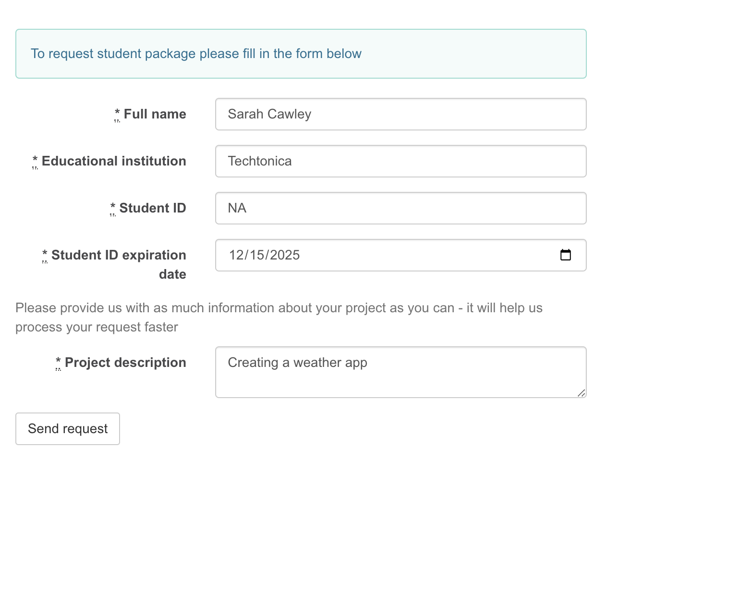

Practice & Review Resources:
🌐Differences between Node.js and the Browser
🎦Promises & APIs
🎦Javascript Promises Tutorial with Examples
🌐All You Need to Know About JavaScript Promises
🌐How to Learn JavaScript Promises and Async/Await in 20 Minutes

Skills you should have at the end of the day:

Restful API
- What is a Restful API?
- A better understanding of APIs

EOD Quiz: Restful API

